1. The figure below is missing a measurement for one line segment. What is the missing measurement?

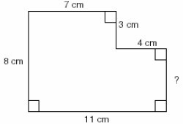

1. If the perimeter of a rectangle is 24 inches and the length of the rectangle is 3 inches, what is the width of the rectangle in inches?
2. The diagram shows the dimensions in feet of a hallway. The hallway is 4 feet wide the whole way. What is the area of the hallway floor?

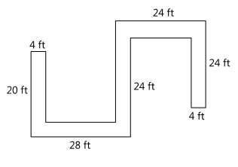

1. A triangle has an area of 42 square meters and a base length of 7 meters.  What is the height of the triangle?

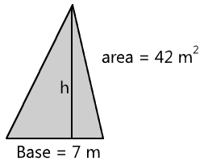

1. The square shown is divided into 4 congruent rectangles. Each of them has perimeter 30 cm. What is the perimeter of the square?

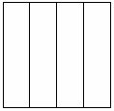

1. Jillian’s backyard is 1200 square feet. She just bought a rectangular trampoline that is 16 feet long. If the trampoline covers 12% of the backyard, then how wide is the trampoline?
2. An 8-inch square of thin paper is folded in half vertically and then horizontally to create a new square. These 2 folds are repeated 5 times each, including the first two folds, to create a tiny square. What is the perimeter of the new square? (An 8-inch square is a square that is 8 inches on each side.)
3. Farmer Judy is creating an oddly shaped rotationally symmetric raised garden bed. For every square foot of garden, she needs 1 pound of manure. How many pounds of manure will she need for this bed? (The dashed lines are to indicate lengths and are not part of the framing.)

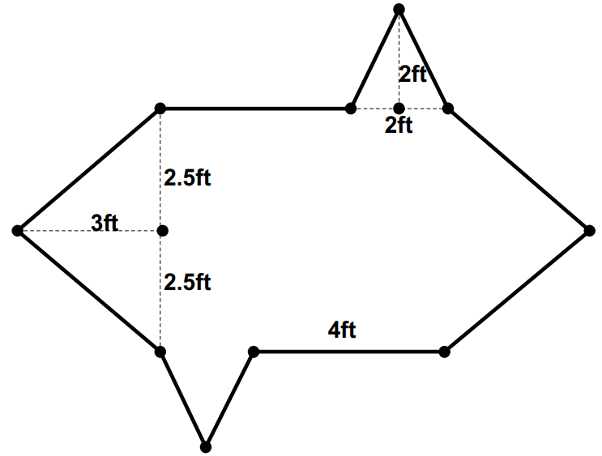

**BONUS PROBLEMS**

1. Trevor and Debby are designing a fort. They notice that if they increase the length of the floor by 2 feet then the floor area will increase by 12 square feet. If they increase the width by 3 feet then the floor area will increase by 24 square feet. What are the dimensions of the floor in their original design?
2. Mr. Smiley, as shown below, is made up of two circular eyes, each with radius one centimeter, and a semicircular mouth with radius 3 centimeters, inside a circular face with radius 10 centimeters. To the nearest square centimeter, how much of Mr. Smiley’s face is not taken up by his eyes or mouth?



1. The regular hexagon below is circumscribed by a circle with a circumference of 8π. Find the shaded area.



1. At a construction site, some workers are rolling a large spool of cable. If the spool is a cylinder with a diameter of 48 inches, how many **yards** will it roll in 12 revolutions along a smooth surface?

**Solutions**

*Note: There are many acceptable strategies to solving each problem. This sheet shows just one strategy.*

1. Since everything is right angles, looking at just the vertical measurements shown, the missing side is 8 – 3 = 5

**Answer: 5 cm.**

1. If the perimeter is 24 inches, then the sum of one length + one width is half of that, or 12 inches.

Since the length is 3 inches, the width must be 9 inches.

9 in.

3 in.

**Answer: 9 inches**

1. Fill in the missing dimensions, knowing that the hallway is 4 ft. wide the whole way. Also, divide up the hallway into non-overlapping rectangles:

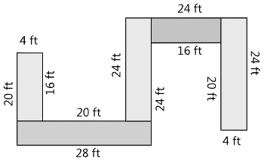

Total area = (4 × 16) + (4 × 28) + (4 × 24) + (4 x 16) + (4 x 24) = 432 ft2

**Answer: 432 ft2**

1. The area of a triangle is (base x height x $\frac{1}{2}$).

7 x h x $\frac{1}{2}$ = 42

So, h = 12

**Answer: 12 meters**

1. Each rectangle has a short side which is ¼ the length of its long side.

Since the perimeter of each rectangle is 30 cm, the sum of the short side + long side = 15 cm.

Therefore the short side is 3 cm., and the long side is 12 cm.

Therefore each side of the square is 12 cm., and the perimeter is 48 cm.

**Answer: 48 cm.**

1. 12% of 1200 ft2 = 0.12 × 1200 = 144 ft2 covered by trampoline

W × 16 = 144

So, W = 9

**Answer: 9 ft.**

1. Each time you fold the paper, the length of the sides get cut in half. So,

Original 8” x 8”

1st fold 4” x 4”

2nd fold 2” x 2”

3rd fold 1” x 1”

4th fold 0.5” x 0.5”

5th fold 0.25” x 0.25”

Perimeter of final square is 0.25 + 0.25 + 0.25 + 0.25 = 1 inch.

**Answer: 1 inch**

1. We need to break apart the garden bed into its individual shapes and calculate the area of each shape. First we start with the large triangles on the left and right sides:

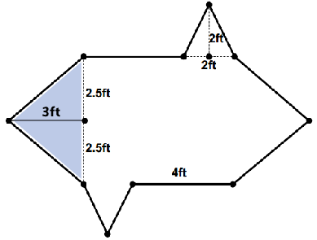

The area of this large triangle is ½×b×h, or ½×5×3 = 7.5 ft2.

Next, the area of the small triangles at the top and bottom: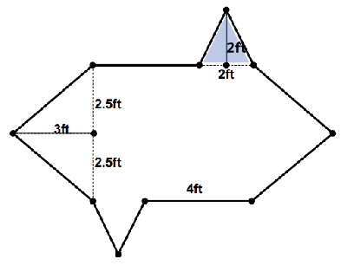

The area of this small triangle is ½×b×h, or ½×2×2 = 2 ft2.

Finally, the area of the large rectangle in the middle:

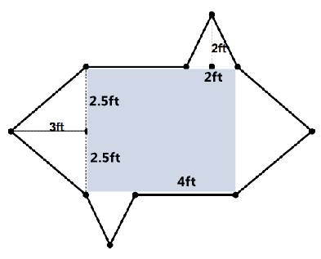

The height of this rectangle is 5ft. The length of this rectangle is 6ft, because we know it’s rotationally symmetrical, and so we have the 4ft length that is given, plus the 2ft which is the base of the small triangle. So, the area of the rectangle is 5×6 = 30ft2.

Adding up all the parts:

Big triangle + big triangle + small triangle + small triangle + rectangle =

7.5 + 7.5 + 2 + 2 + 30 = 49 ft2

Because we need exactly 1 pound of manure per square foot, we will need 49 pounds of manure.

**Answer: 49 pounds**

1. Drawing out the fort:

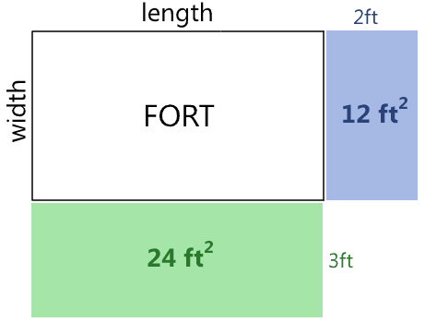

The black rectangle shows the original fort, with length and width marked, although we do not currently know the values of the length and width.

If we increase the length of the original fort by 2ft, then the area of the fort increases by the amount shown in the blue rectangle, which is 12ft2. Therefore the width of the original fort must be 6ft (since area = length × width).

If we increase the width of the original fort by 3ft, then the area of the fort increases by the amount shown in the green rectangle, which is 24ft2. Therefore the length of the original fort must be 8ft (since area = length × width).

**Answer: 8ft x 6ft**

1. The area of the large circle is 100π. Subtract the areas of the two eyes (1π each) and the semicircle mouth (4.5π) to get 93.5π. Using π=3.14, 93.5 x 3.1415 = 293.73, which rounds to 294 sq. cm.

**Answer: 294 sq. cm.**

1. Looking closely at the picture, we can tell that exactly ½ of the figure is shaded. Knowing that the circumference of the circle is 8π, using the formula C = 2πr, we can deduce that the circle’s radius is 4. Using the formula for the area of a circle ($A=πr^{2}$), we find that the area of the entire circle is 16π, therefore ½ of the total area would be 8π (or 25.133).

**Answer: 25.133 or 8π**

1. If the cylinder’s diameter is 48 inches, its circumference is 48π inches. In 12 revolutions, it will travel 576π inches. 576π inches = 48π feet = 16π yards.

**Answer: 50.27 or 16π yards**